Final Assignment Task1:

Write the spring boot for login application. Database will have USER table and it will have the list of userids and passwords. Users credentails will be validates against this data. Data to the controller should be sent using POST method. This application should be tested using POSTMAN.

User Class

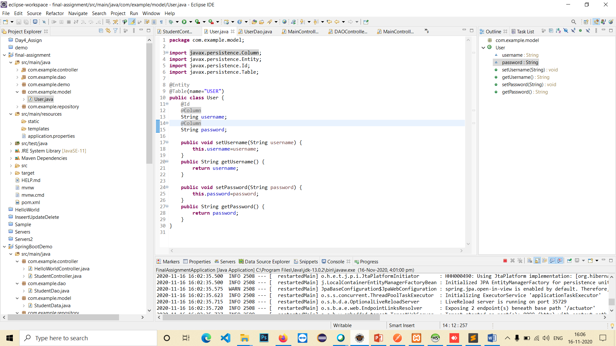

Dao Service

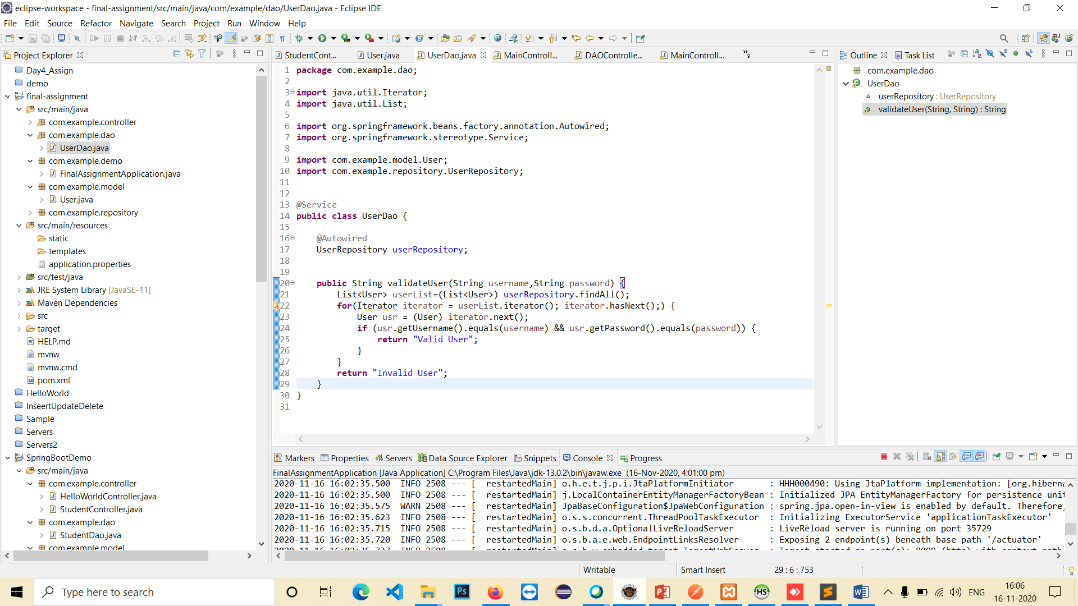

Controller

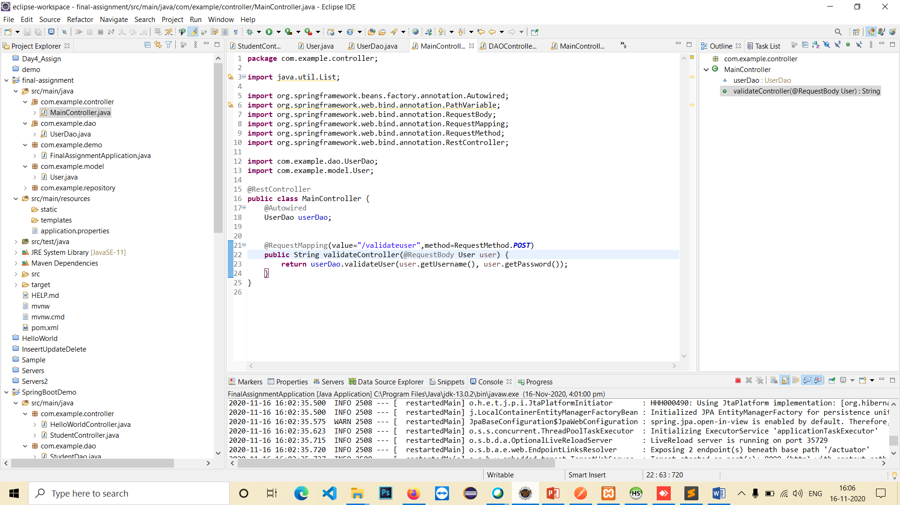

Repository

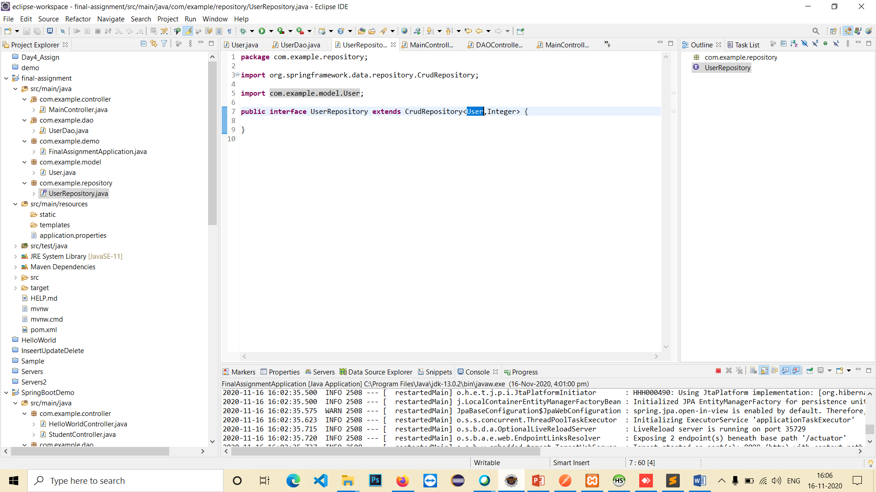

Results On PostMan:

Valid Users are:

Username:admin

Password:admin

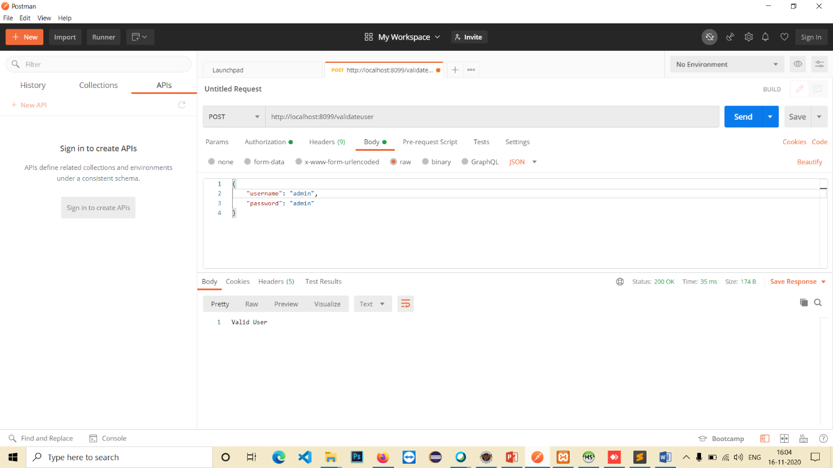

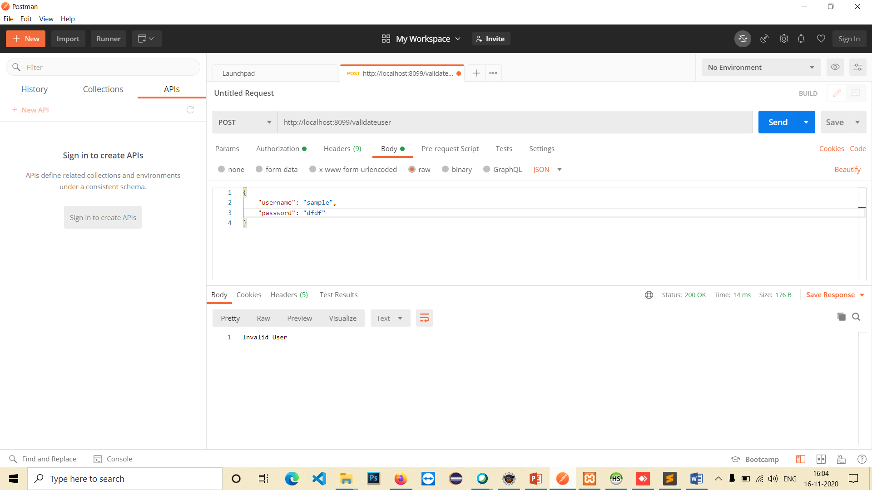

Database

